Olivia Young, Eden Lifshatz, Jewels Hatchard

Section 1

Vocabulary

Position: The location of an object

Reference point: A location to which another location is compared

Motion: An object's change in position relative to a reference point

Speed: The distance traveled divided by the time interval during which the motion occurred

Vector: A quantity that has both size and direction.

Velocity: speed of an object in a specific direction.

What does GFF stand for?

G- Given. Write what the equation is already giving you. (Ex: distance and time.)

F- Find. What do you have to find out? (Ex: speed)

F- Formula. What is the formula to figure out your answer? (Ex: d/t=s)

Section 2 Vocabulary

Acceleration: The rate when velocity changes. If it accelerates it does so in speed, direction, or both. (acceleration = final velocity-starting velocity)

time
Centripetal Acceleration: the acceleration directed toward the center of a circular path.

Negative Acceleration: when an object slows down, it goes from a high velocity to a low velocity.

Scalar vs Vector:

Scalar doesn't relate to direction (related to speed).

Vector relates to direction, acceleration, and velocity.

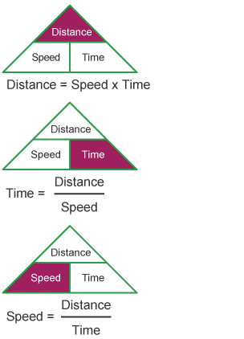

Section 3

Vocabulary

Force: A push or pull

Net force: The combination of all forces action on one

Inertia: The tendency of all objects to resist change in motion

Newton's Laws

- (Inertia) An object at rest will stay at rest and an object in motion will stay in motion, in the same direction and speed unless acted on by an unbalanced force.
- The acceleration of an object depends on the mass of the object and the amount of force applied. F=ma.(f=force, m=mass, a= acceleration). Maintain the same speed, force and velocity unless it experiences an unbalanced force.
- Whenever one object exerts a force on a second object, the second object exerts an equal and opposite force on the first.

